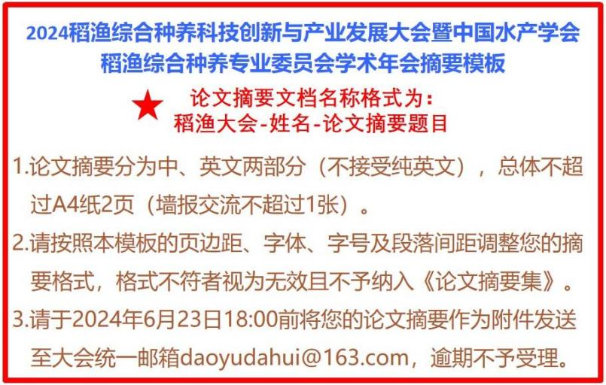
附件1
不同稻田综合种养模式下产量形成特点及其稻米品质和经济效益差异
车阳¹，邢志鹏¹，窦志¹，徐强¹，胡雅杰¹，郭保卫¹，魏海燕^{1,2}，高辉^{1,2}，张洪程^{1,2*}
¹江苏省作物栽培生理重点实验室，扬州大学，扬州 225009；
²江苏省粮食作物现代产业技术协同创新中心，扬州大学，扬州 225009

摘要：为探明不同稻田综合种养模式下水稻产量、光合物质生产、品质和经济效益特征及差异, 本研究于2018年和2019年以当地代表性优质水稻南粳9108为材料, 设置稻虾(rice crayfish, RC)、稻鳖(rice turtle, RT)、稻鳅(rice loach, RL)、稻鲶鱼(rice catfish, RF)、稻锦鲤(rice koi, RK)和稻鸭(rice duck, RD)等6种主流和当地特色的稻田综合种养模式, 与稻麦两熟模式下水稻生产(CK)进行对比, 系统研究多种类型稻田综合种养模式对水稻产量及其构成、光合物质生产特征、稻米品质与经济效益的影响。综上所述, 稻田综合种养是一种稳产提质增效的稻作生产方式。
关键词：稻田综合种养；产量；光合物质生产；品质；经济效益

Characteristics and difference of rice yield, quality, and economic benefits under models of plant-breeding in paddy fields
Yang Che¹, Zhipeng Xing¹, Zhi Dou^{1,3}, Qiang Xu¹, Yajie Hu¹, Baowei Guo^{1,3}, Haiyan Wei^{1,2}, Hui Gao^{1,2}, Hongcheng Zhang^{1,2*}
¹ Jiangsu Key Laboratory of Crop Genetics and Physiology, Yangzhou University, Yangzhou 225009, China;
² Co-Innovation Center for Modern Production Technology of Grain Crops, Yangzhou University, Yangzhou 225009, China;
Abstract: To explore the characteristics and differences in yield, photosynthetic matter production, quality and economic benefits of rice under different modes of comprehensive planting-breeding in paddy fields, six modes including rice crayfish (RC), rice turtle (RT), rice loach (RL), rice catfish (RF), rice koi (RK), and rice duck (RD) were arranged using Nanjing 9108 (a high-quality rice variety) as the experimental material in 2018 and 2019. Comparing these modes with rice cultivation under rice–wheat rotation (CK), the effects of different modes of comprehensive planting-breeding in paddy fields on quality, yield and yield component of rice, characteristics of photosynthetic matter production, and economic benefits were systematically investigated in this study. In conclusion, comprehensive planting-breeding in paddy fields was an alternative rice planting mode, that could guarantee a stable rice yield, improve rice quality, and increase the comprehensive benefits.
Key words: Comprehensive planting–breeding in paddy fields; Rice yield; Characteristics of photosynthetic matter production; Quality; Economic benefit

